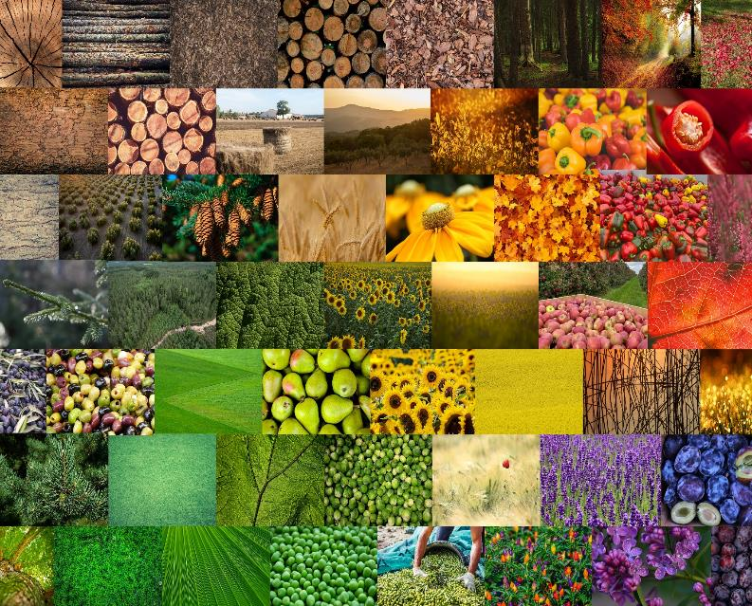

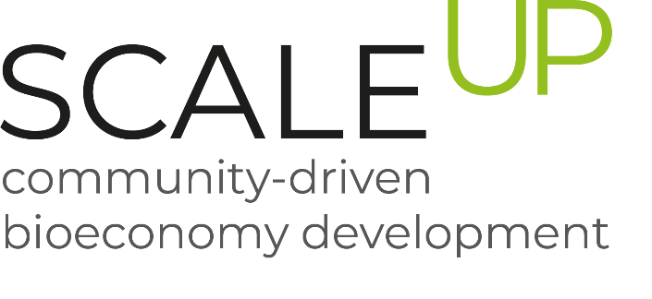

WS5 Training Programme Protocol

**Social innovations in rural areas:**

**Session #3: Recreating the food system through social innovations**

25 June 2024

**Session 3: Recreating the Food System through Social Innovations**

The third and final session on social innovations in rural areas was held on June 25, 2024, from 9:00 a.m. to 12:00 p.m. CET. This session centred on reconstructing the food system through social innovations.

The proceedings commenced with a welcome address and the agenda presentation by Julia Kosikowska from UNIMOS Alliance. The moderator provided an overview of the SCALE-UP project, a three-year EU-funded initiative aimed at augmenting the capacity of regional partnerships to develop bio-based products, strengthen the collaboration among various stakeholders, enhance knowledge regarding nutrient recycling, raise awareness of the impacts of the bioeconomy, and promote a sustainable regional bioeconomy. Noteworthy mentions from the project included six focal regions working on different biomass streams, namely Northern Sweden, Mazovia, French Atlantic Arc, Upper Austria, Strumica, and Andalusia.

Following this, Julia Jägle from the Ecologic Institute delivered the keynote address titled "Recreating the Food System Through Social Innovations: New Cooperation and Pooling Approaches." The address delved into KOPOS's activities to develop novel cooperation models for sustainable agri-food systems, addressing challenges such as land access and short value chains. Notably, Jägle emphasised the significance of pooling resources and cooperation to bolster sustainability in food systems.

Subsequently, Marion Francois presented the initial case study on the Short Food Supply Chain in Normandy. The presenter discussed the equilibrium between food production and local consumption, addressing environmental and socioeconomic menaces. Marion underscored the indispensability of knowledge sharing and collaboration with public tools to address these challenges.

The session proceeded with Patrycja Nierada's case study on the REBREAD project, concentrating on transforming leftover bread into valuable resources. Nierada expounded upon innovative research and development services and local implementations aimed at eradicating bread waste by 2040 through fungi fermentation for alternative proteins, highlighting the project's tangible impact, including partnerships with retailers like Żabka in Poland.

Following the case studies, a brief discussion was held, culminating in a feedback segment where participants shared their insights and responses. Upcoming sessions were also announced, including two additional workstreams this autumn: one addressing the governance of regional bio-based systems and another focusing on strategies to address social, ecological, and economic trade-offs in regional bioeconomy development. Attendees were encouraged to provide feedback via QR codes or links in the chat. Subsequently, discussions moved into breakout rooms moderated in participants' native languages, centring on regional needs and challenges related to food waste, barriers to overcome, specific issues in the current food system, and envisioning an idealised food system characterised by social innovation.

Overall, the session effectively underscored the transformative potential of social innovation in rural communities, imparting valuable knowledge and cultivating collaborative discussions among participants.

**BREAK-OUT ROOMS**

1.   WHAT IS YOUR PERSONAL EXPERIENCE ON THE TOPIC OF FOOD WASTE?

**NORTH MACEDONIA**

In the Strumica region, several measures have been implemented to address food waste. Excess food from kindergartens is given to social kitchens, providing meals for those in need. Farmers donate surplus produce, such as corn, cabbage, and tomatoes, to livestock, particularly pigs, reducing waste and feeding animals.

Social-type restaurants support households by providing meals, and 700 mini-scale composting machines have been distributed to households to compost food waste. Used oil is collected for biofuel production and exported to Austria, showcasing international cooperation. Excess fruit production is used to make alcohol, ensuring no produce goes to waste.

On the national level, coffee grounds are repurposed into furniture, cups, paints, biofuels, and organic compost.

**POLAND**

The insights from the Polish break-out session underscored the pressing need for more deliberate and responsible product consumption. The responses were sorted based on the locations where food wastage is prevalent.

Food is often squandered at home due to excessive purchasing, neglecting to use leftovers or inadequate meal planning. Fresh produce frequently goes bad before consumption, and leftover meals usually languish forgotten in the refrigerator.

Local markets and grocery stores frequently discard perfectly good food in the community due to strict aesthetic standards or impending expiration dates. Community initiatives, such as food banks and donation programs, play a crucial role in mitigating this form of wastage.

Food waste is rampant in workplace environments, particularly cafeterias and events. Catering services often result in surplus food not always repurposed or given to those in need.

**SPAIN**

In the Andalusian regional session we had two main speakers. Their experiences with food waste were:

1. Utilisation of food waste in the agri-food sector at a non-industrial level. Their projects aim to provide an alternative solution to food surpluses that cannot normally be used.

2. Valorisation based on composting. They recover waste from supermarkets (e.g. fruit) and municipal waste.

**UPPER AUSTRIA**

As the Upper Austrian Break-Out Room consisted mostly of local bakers from chains of different sizes, this question was one they were quite familiar with. Their responses reflected the findings of earlier Scale-Up activities such as the nutrient availability report: food waste is a huge problem for these producers that they face daily and where they are still not at an ideal solution.  
  
An interesting point here is the fact that some of these bakeries do not only sell within their own shops but also to supermarkets. In those cases, not every supermarket automatically becomes responsible for the waste created, some chains have special contracts that force the bakeries to buy back unsold products, leaving them with an even more inconsistent and difficult to manage amount of food waste at quite a large level.

1. WHICH HURDLES HAVE TO BE OVERCOME? WHAT SPECIFIC PROBLEMS IN THE CURRENT FOOD SYSTEM REQUIRE SOCIAL INNOVATION?

**NORTH MACEDONIA**

In the Strumica region, several hurdles must be overcome to improve the food system, which necessitates social innovation. One significant challenge is the selection and separation of food waste. Currently, food waste is not consistently separated into designated bins, making it difficult to manage and recycle effectively. This lack of separation hinders the efficient processing and repurposing of food waste into valuable resources like compost or biofuel.

Another issue is the organisation of records for food surpluses and their redirection for alternative uses at the local level. A systematic method for tracking and managing excess food has not been established. Without a proper record-keeping system, it is challenging to identify and redistribute surplus food to areas where it can be utilised, such as social kitchens, livestock feed, or production of biofuels and compost.

Moreover, the absence of a cohesive food system chain exacerbates these problems. The current food system lacks a structured chain that connects producers, distributors, and consumers in a coordinated manner. This disjointed system leads to inefficiencies and missed opportunities for reducing food waste and optimising resource use.

**POLAND**

The current food system faces several significant challenges that necessitate social innovation. These hurdles include a lack of awareness among individuals regarding the extent of food waste and its environmental impact, as well as infrastructure issues such as inadequate facilities for storing and redistributing surplus food. Logistical challenges in coordinating food collection and redistribution and societal norms prioritising abundance over efficiency further contribute to the issue's complexity. Economic barriers, such as financial disincentives for businesses to donate food due to perceived costs or liabilities, also present further obstacles.

Furthermore, specific problems within the food system include overproduction and surplus due to farmers' excess production to hedge against crop failure or meet demand peaks, as well as distribution inefficiencies leading to spoilage before food reaches consumers. Consumer habits, such as bulk purchasing and inadequate portion management at home, also contribute to food waste. Moreover, supermarkets' rejection of perfectly edible food due to cosmetic imperfections and the lack of supportive policies for food donation and redistribution add to the challenges in the current food system.

**SPAIN**

The main barriers and solutions identified include:

- The lack of digitalisation of the production system.

- The lack of adaptation to digital change by some actors in the value chain. The need for training and adaptation.

- Lack of adaptation to demand to avoid the production of surpluses.

- The need for producer associations and the promotion of local production and consumption to foster the local economy.

- The need for investment in R&D to promote the valorisation of waste.

**UPPER AUSTRIA**

There are quite a few hurdles that can be observed in Upper Austria and the related food system. Education is definitely still a topic that is not being addressed enough, not just from the perspective of bringing the topic into schools and spreading it among children and students but also in terms of businesses lacking the internal drive and motivation. However, especially when it comes to education, the lever of social innovation is quite big and the combination of new business opportunities with reduced food waste also have the potential to gather the attention of companies.

A second point mentioned are supply chains and by extent logistical challenges in redistribution. Storage and transportation issues at the beginning of the supply chain can lead to unnecessary waste which could be avoided with better planning and forecasting. Subsequently, towards the end of the lifecycle of the product, often times the lack of infrastructure to quickly and efficiently redistribute so-called food waste before it actually becomes waste also contributes greatly to the amount of food thrown away. Potential social innovations here can be found predominantly in more regional, “small scale” approaches with lower quantities and shorter transportation routes.

1. WHAT COULD AN IDEALISED FOOD SYSTEM OF THE FUTURE LOOK LIKE THAT IS CHARACTERISED BY SOCIAL INNOVATION? WHAT STEPS ARE NECESSARY TO REALISE HIS VISION?

**NORTH MACEDONIA**

In envisioning an idealised food system of the future characterised by social innovation, several transformative steps are essential:

**Utilisation of food waste as secondary products:** Food waste should be transformed into valuable secondary products like compost, biofuels, and animal feed, reducing landfill waste and environmental impact.

**Efficient waste segregation:** Rigorous waste segregation practices ensure organic waste, including food scraps and agricultural residues, is diverted adequately for recycling or alternative uses.

**Redirection of lower-grade products:** Products unsuitable for direct market placement, such as small or irregular fruits, are repurposed into preserves, juices, or syrups, minimising waste and maximising resource efficiency.

**Engagement of proactive stakeholders:** Stakeholders at all levels collaborate on reducing food waste through awareness and proactive measures supported by policies and incentives.

**Strategic planning for waste management:** Comprehensive plans and policies are developed to set targets and implement measures that promote sustainable food practices and minimise waste generation.

This future food system vision prioritises sustainability, efficiency, and collaborative innovation to effectively address global food waste challenges.

**POLAND**

Envisioned Attributes of an Idealized Food System:

a) Circular Food Economy: This model's paramount objective is to curtail waste and efficiently repurpose or redistribute surplus food, fostering a sustainable and streamlined food cycle.

b) Community Engagement: Robust community networks facilitate food sharing and redistribution initiatives, cultivating a collective commitment to waste reduction.

c) Sustainable Practices: Emphasis is placed on embracing sustainable agricultural methodologies and minimising the distance food travels from production to consumption, thereby mitigating the environmental footprint of the food supply chain.

d) Technology Integration: Strategically integrating advanced technology is imperative for optimising food production processes, fortifying distribution networks, and proficiently managing food waste.

e) Education and Awareness: Continuous educational endeavours and awareness campaigns are pivotal in informing and mobilising the public to address food waste challenges and embrace sustainable practices.

Crucial Steps to Realize This Vision:

a) Policy Reforms: Implementing policies incentivising food donations, waste reduction, and sustainable practices is essential for effecting systemic change conducive to realising the idealised food system.

b) Infrastructure Advancement: Establishing infrastructure geared toward efficient food storage, transportation, and redistribution is indispensable to facilitate the seamless flow of food resources.

c) Technological Solutions: Strategic investment in innovative technology to enhance inventory management, forecast demand, and optimise distribution channels is instrumental in fortifying the resilience and efficiency of the food supply chain.

d) Cultural Transformation: It is paramount to cultivate a cultural shift towards elevating the value of food and minimising waste through comprehensive educational programs and community engagement initiatives.

e) Partnerships and Collaborations: To address food waste challenges comprehensively, it is imperative to cultivate synergistic partnerships among governmental bodies, non-governmental organisations, businesses, and local communities.

f) Research and Innovation: Sustained support for research initiatives aimed at pioneering solutions to diminish food waste and elevate the overall efficiency of the food system is critical.

**SPAIN**

At the Andalusian regional session, several ways in which social innovation could help the food system were identified, including the following:

- The need to involve the different actors in the value chain. Among them, cooperatives are of enormous importance as they can act as sectoral consolidators.

- Seek the human approach to understand the reality and needs of the companies in the sector and act accordingly.

- Promotion of innovative solutions that already exist in the market. For instance, the promotion of platforms that prevent food waste, as well as the incorporation of the outcomes of various European projects focused on this topic

**UPPER AUSTRIA**

A lever we too see in Upper Austria is a circular economy approach. “Waste” is truly only waste when the item in question has no cycle to go into after its initial use. There are some great local examples such as HochBROTzentig that already show how to turn a “waste” product into a new product’s raw material, a resource rather than an inconvenience.

Another suggestion was to strengthen connections among stakeholders in the system, from farmers to retailers to consumers. By building better networks that are integrated and work with one another rather than in competition or, even worse, completely past each other, waste can be reduced significantly and the aforementioned logistics and supply chain issues could be mitigated much easier and quicker.

Lastly, we circled back once more to the topic of education as this is also where the second question comes into play. Regardless of what suggestion is being made, it takes knowledgeable people with a passion and an understanding for the consequences to make such a vision reality. And this education is necessary regardless of age, gender or occupation. A vision like this works like a machine with many little gear wheels turning and it takes every wheel working correctly for the machine to function smoothly.

**Cross-regional conclusions/learnings**

**What can we do?**

o   **Utilise Food Waste Effectively:** We can transform food waste into valuable secondary products such as compost, biofuels, and animal feed to minimise landfill waste and reduce environmental impact.

o   **Enhance Waste Segregation:** Implementing rigorous waste segregation practices can ensure that organic waste is diverted adequately for recycling or alternative uses, optimising resource utilisation.

o   **Promote Local Production and Consumption:** Strengthening local food systems through promoting local production and consumption can help reduce food miles and enhance the sustainability of food supply chains.

o   **Adopt Digital Solutions:** Digitalizing food production systems and training stakeholders to adapt to digital changes can streamline processes and reduce waste.

o   **Support Research and Innovation:** Investing in research and development to promote innovative solutions for waste valorisation and sustainable practices can drive systemic improvements in the food system.

The key takeaways:

o   **Community Engagement:** Establishing strong community networks for sharing and redistributing food helps promote a commitment to reducing waste and adopting sustainable practices.

o   **Sustainable Practices:** Embracing sustainable farming methods and minimising the distance food travels are essential for reducing the environmental impact of food systems.

o   **Technology Integration:** Incorporating advanced technologies to optimise food production, distribution networks, and waste management can improve the efficiency and sustainability of food systems.

o   **Policy and Infrastructure Development:** It is vital to implement policies that encourage food donations, waste reduction, and sustainable practices and establish efficient food storage and redistribution infrastructure.

o   **Education and Awareness:** Continuous educational programs and awareness campaigns are essential for informing and mobilising the public and stakeholders to adopt sustainable food practices and reduce waste.

o   **Collaborative Approaches:** Encouraging collaboration among stakeholders—such as governments, NGOs, businesses, and local communities—can create a supportive ecosystem for social and economic revitalisation through reduced food waste and improved sustainability.

**Participant feedback**

At the end of the training session, the participants were asked to fill in a short survey to evaluate the training session. The three participants that answered the survey (2 from Spain and 1 from Poland) rated the quality of the training session between a 3 and a 4, with 4 being excellent. They mentioned that they liked the presentations and that the presentations were very professional. They also mentioned that the information in the presentations was very clear and didactic. When asked what could have gone better, one of the participants answered that the presentations could be shorter. However, they also mentioned that the work done is extensive and it could be difficult to summarize. Compared to the previous sessions in the workstream, one of the participants answered that the presentations were longer and more detailed.

When asked how easy the presentations were to follow, the participants answered with a 3 or a 4, meaning that the presentations were relatively easy to follow. The presentation that all three participants liked best was that of ‘Rebread’, regarding bread waste management and that of the pool of producers.

One of the participants mentioned that even though the topic of the project is not in their current field, they believe that the webinars are very useful as they can hear about the experiences and future actions of the participants.

Two of the survey participants mentioned that they are working in agriculture, while one is working in research.

**Participants:**

If you wish to get in touch with one of the participants from this session, please contact someone in the SCALE-EP consortium.

Cover page photos © BFR, CTA, UNIMOS, franceagritwittos.com, and pixabay.com